**Empathic and Numerate Giving:**

**The Joint Effects of Images and Charity Evaluations**

**Authors: Robin Bergh (Harvard, Uppsala) and David Reinstein (Exeter)**

**November, 2019**

# Abstract

Helping behaviors are often driven by emotional reactions to the suffering of particular individuals, but these behaviors do not seem to be upregulated when many people need help. In this paper we consider if these reactions are also “innumerate” to information about how charities spend their money. Across six experiments we examined how images of identified victims interact with information about charity efficiency (money toward program) and effectiveness (program outcome). We further examined if the images primarily get people to donate (yes/no), while efficiency/effectiveness might provide a tuning mechanism for how much to give. Results showed that images influenced the propensity to donate and induced participants donate their full bonuses, indicating heuristic effects. Efficiency and effectiveness information had no effects on donations.

*Keywords:* Prosocial behaviors, identified victims, dual-process perspectives, empathy, deliberation, efficiency, effective altruism

# Introduction

Reacting emotionally to someone else’s suffering, accompanied by an urge to alleviate it, can be a potent force behind helping behaviors (e.g, Batson, Duncan, Ackerman, Buckley, & Birch, 1981; Dovidio, Piliavin, Schroeder, & Penner, 2012). Some scholars have argued, however, that such emotions can ultimately do more harm than good. For instance, Bloom (2016) argued that “empathy is a spotlight focusing on certain people in the here and now […] It is innumerate, favoring the one over the many […] If our concern is driven by thoughts of the suffering of specific individuals, then it sets up a perverse situation in which the suffering of one can matter more than the suffering of a thousand” (pp. 9 & 89).

A proposed cure for these perversities follows from Enlightenment philosophy: Give people better information to guide their helping behavior, and encourage them to think rationally, rather than following their gut feelings (e.g., Bloom, 2016; Singer, 2015). In this paper we take a step back from normative arguments about what people *should do*, to consider an empirical question: what do donors *actually* *do* when facing empathy-invoking appeals and information that invites logical deliberation? We examine this question by differentiating mental processes that are spontaneous (empathic responses) from ones that are more deliberate (evaluating the efficiency or effectiveness of a charity).

## The Innumerate (but Generalizable) Features of Empathy

The description of empathy as innumerate fits the notion of an emotional heuristic (e.g., Slovic, Finucane, Peters, & MacGregor, 2007). Although some definitions and aspects of empathy may involve deliberation (e.g. perspective-taking; Davis, 1983), we focus on the emotional reactions associated with an urge to relieve the suffering of someone else (see also Batson et al., 1981; Singer & Klimecki, 2014). In this sense, empathy is fast and spontaneous, and also evident in species with limited analytic abilities (Preston & de Waal, 2002). Like other spontaneous mental processes, empathic reactions are prone to cognitive biases (Bloom, 2016).

Perhaps the clearest bias is that empathy for a *particular* person’s distress leaves one insensitive to the *number* of people that can be helped. There is strong evidence that people offer more aid to specific, identifiable victims than anonymous, statistical victims (called the *identified victim effect*; see e.g., Kogut & Ritov, 2005; Lee & Feeley, 2016; Small, Loewenstein, & Slovic, 2007). However, empathy toward one person may still benefit other people sharing the identified victim’s situation. Similar to Bloom’s (2016) analogy of a spotlight, we ask whether empathy is like a laser beam directed at one person only, or alternatively, like a diffuse flashlight focused on one person but partially highlighting others as well.

Identified victim effects clearly benefit the highlighted individuals (for a meta-analysis, see Lee & Feeley, 2016), but benefits for others remain unclear. For instance, Small et al. (2007) described how “any money that you donate will go to Rokia [the identified victim]” (p. 152), while Kogut and Ritov (2005) asked whether participants “were willing to contribute money to save the victim(s) lives” (p. 160). Two studies focused on donations not earmarked for the identified victim have generated mixed results (see Erlandsson, Björklund, and Bäckström, 2015; Lesner & Rasmussen, 2014). Those studies also involved hypothetical giving, or relied entirely on previous donors as participants, which complicates the generalizability of the findings (see also next heading).

The notion that empathy is innumerate also informs discussions about rational and effective helping behaviors. If empathy is innumerate it should not only be insensitive to the numbers of victims, but to *any* numerical information – such as the proportion of a charity’s revenue that goes to its programs (henceforth efficiency), and the ultimate outcomes these programs yield (henceforth effectiveness).

## Charity Efficiency and Effectiveness

Effectiveness (versus efficiency) is a more direct indicator of the positive impact of a donation, but it is also harder to quantify (Caviola, Faulmüller, Everett, Savulescu, & Kahane, 2014; Singer, 2015). Efficiency can be calculated based on tax records of revenues and overhead costs, and several websites rate charities based on this information (e.g., Charity Navigator and GuideStar). However, a donor wishing to do the most good should also consider the indirect benefits of “inefficient” charity spending (e.g. fundraisers increasing a charity’s revenue). Furthermore, new (“marginal”) donations may generate different results as earlier ones (see e.g., Steinberg & Morris, 2010). Thus, some scholars argue that efficiency-oriented donors typically focus on the wrong arithmetic (e.g., Singer, 2015; Steinberg, 1986). Nevertheless, efficiency and effectiveness evaluations both involve numerical thinking, and both are informative (if correctly specified) about the impact per dollar donated *when everything else is equal*. Thus, a numerate donor who cares about impact should consider both types of information when other factors are kept constant. But do they?

The empirical findings are mixed. While several correlational studies suggest that more efficient charities receive more donations (for a review, see Bekkers & Wiepking, 2011), this association could be due to confounds, such as the size and familiarity of a charity. Big charities often have smaller overhead costs (e.g., Bowman, 2006), and there are many reasons why they generate more donations. Some work further suggests that changes in charity ratings lead to changes in charity revenues (e.g., Gordon, Knock, & Neely, 2009; Yörük, 2016), but it is unclear if this is driven by efficiency evaluations per se. For instance, people might respond to the number of stars given to a charity without deeply considering what these stars represent.

Some lab experiments provide evidence that people favor efficient charities in forced choice questions, especially when the contrasts are very clear (0% vs 50% overhead; Gneezy, Keenan, & Gneezy, 2014). Yet, other studies suggest that people attend to efficiency information as a potential excuse for not to donate (Exley, 2016), and beliefs about effectiveness are colored by subjective preferences (Berman, Barasch, Levine, & Small, 2018). Further evidence suggests that people give based on a subjective sense of making a difference (e.g., when they can help a charity across the finish line with a fundraising goal; Cryder, Loewenstein, & Scheines, 2013; Cryder, Loewenstein, & Seltman, 2013) rather than based on objective metrics of charity efficiency or effectiveness.

Field experiments suggest that overall, donors do not contribute more when they are informed (versus not informed) about either charity efficiency (Parsons, 2007), or effectiveness (Karlan & Wood, 2017). While Karlan and Wood (2017) did find that those who had previously donated large amounts gave more when they received effectiveness information (and Parsons found similar effects for efficiency and prior donors), the reason for this effect is unclear. For example, large/frequent donors may experience a greater pressur­­e to donate in light of *any* new positive information. Indeed, the compliance literature suggests that people who have already committed to buy something are more easily persuaded in a later stage to pay more for the same product (see e.g., Cialdini & Goldstein, 2004; Cialdini & Griskevicius, 2010). There is little reason to believe that donors, unlike regular buyers of products, are immune to compliance pressures.

Still, people might use more deliberate thinking when deciding how *much* to give, (thus being susceptible to information about charity efficiency/effectiveness) as compared to when deciding *whether* to donate. This may be particularly the case for regular large donors, who may not dwell on deciding *whether* to donate again. From this perspective, major donors might not be more dispositioned toward effective giving (as interpreted by Karlan & Wood, 2017). Rather, small irregular donors may be pre-occupied with a pre-requisite, potentially more emotion-laden question: Should I support this cause at all?

## Interactions between Empathic Emotions and Deliberation

We further considered whether combining an empathy-induction with efficiency/ effectiveness information leads to greater donations than the empathy-induction on its own. In fact, the literature indicates a potential for a “negative” interaction, in which a rational appeal interferes with the spontaneous empathic reaction and leads to less donations than an empathic appeal alone (Small et al., 2007). Other research further suggests that people are prosocial and cooperative when they make more spontaneous decisions, and conversely, act more self-serving when they ponder more on their decisions (e.g., Rand et al., 2012; Rand, 2016; but see also Tinghög et al., 2013).

This research raises an unresolved question: Does the empathy-disruption occur for any deliberation, or only for certain types of deliberation? For instance, spending cognitive resources on a task that is irrelevant for charitable giving may create a backlash for empathy-driven giving (see Small et al., 2007, study 4), but deliberating on charity effectiveness may not do so.

## The Current Studies

Our research addresses a series of unsettled questions about the role of spontaneous empathy and deliberate thinking in charitable giving. When people are empathically moved to help a particular individual, they consider if their actions will have the desired effect or not (i.e. effect information facilitates empathically motivated help; e.g., Sibicky, Schroeder, & Dovidio, 1995). However, it remains unclear whether effects of empathy on donations also depend on information about how efficiently/effectively charities spend their money. This information may amplify empathy-based giving (as triggered by images of particular victims) – a “*positive” interaction* (similar to the findings for interpersonal helping behaviors). On the other hand an evaluation of efficiency/effectiveness information may disrupt emotionally-induced generosity – a “*negative” interaction* (similar to findings by Small et al., 2007, suggesting that analytic thinking decreases donations to identified victims). Empathy and efficiency/effectiveness information may also operate independently, showing *no interaction*.

We also examined hypotheses about the respective main effects (in addition to the interactions). Whereas conventional wisdom suggests that images of identified victims generates help toward many others in the same situation (see also Slovic, Västfjäll, Erlandsson, & Gregory, 2017), some have argued otherwise (Bloom, 2016; Lesner & Rasmussen, 2014). We predicted that victim images increase donations, particularly by increasing the willingness to donate anything (versus nothing), pushing participants past the initial hurdle to “do something”. This would be consistent with an innumerate and heuristic nature of emotionally-driven prosociality (Bloom, 2016; Slovic, 2010).

To the extent that efficiency/effectiveness information increases donations, it seems reasonable that this would instead impact *amounts* given. To test these different effects, we first estimated the effects of our treatments on donation incidence (donating: yes/no), and secondly on non-zero amounts (i.e. two outcomes equivalent to those estimated in a two-part model; see Humphreys, 2013; see also supplementary materials for alternative modeling strategies).

# Methods

## Participants

Except for study 6, all experiments involved participants from Amazon Mechanical Turk. We recruited Americans with a hit approval rating of 98% or higher and 100 hits or less. The latter restriction aimed to assure they were somewhat naïve about psychological experimentation Respondents were excluded if they failed simple attention checks (e.g., “to monitor quality, please respond with a seven for this item”). There were two such screening questions in studies 1-4; study 5 had one; study 6 used a different kind of attention check.

Study 6 was involved (mainly student) members of a study pool at a British university, invited to complete an online Omnibus survey (see <https://osf.io/cvrn4> for pre-registration). Here we measured attentiveness by asking participants to recall the global regions that one of the charities operated (Latin America and Africa). The results reported below focuses on participants who recalled at least one of these regions. In the supplementary materials we also report results for the full sample. Results are similar for each of these subsets.

Based on these inclusion and exclusion criteria the final sample sizes were 398, 614, 611, 608, 433, and 319 in Studies 1-6, respectively (variation tracking design complexity). The percentage of women varied between 57 and 64%, the median age across all studies was 23-30 years (*SD*s from 9.55 to 12.05). In Study 1, 2, 3, and 5, participants received $1.50 as a baseline payment, whereas those in the slightly longer Study 4 received $2. Baseline payments could not be donated within the study. In addition, participants were offered a bonus payment, or entered into a raffle, from which they could donate (main dependent variable). Studies 1 and 2 involved a bonus of $3, Studies 3 and 4 involved a raffle for $50 (1:25 odds in Study 3 and 1:100 in Study 4). Study 5 had a bonus of $5. Study 6 involved a raffle for one of 20 Amazon £50 gift cards (odds of winning not disclosed, roughly 1:20 ex-post).

We aimed to have around 100 participants per experimental cell. The experiments were originally designed to examine effects of victim imagery and efficiency information for the whole range of donation amounts, and powered accordingly. In ordinary least-squares regression, we would have a power of .80 for detecting a weak effect (*Δ* *R*2 = .02) in a 2 × 2 between-subject design with 400 participants, or .93 in a 2 × 3 design with 600 participants (estimated in GPower 3.1; Faul, Erdfelder, Lang, & Buchner, 2007). Taking all main and interactions into account, the power would have been .65 and .76. Given that the realized distribution of donations was trimodal (most people giving nothing, half, or everything), we updated some analytic procedures, leading to lower ex-post power for some analyses. For example, analyzing mid-range donation amounts (roughly normally distributed), and setting aside the minimum and maximum donations, the actual power to detect a small effect, given the current *Ns*, would be >.70 for one predictor and >.45 for all five predictors in the 2 × 3 design (all other analyses had better power). To get better estimates of effect sizes and confidence intervals we also conducted mini meta-analyses (see Goh, Hall, & Rosenthal, 2016).

## Designs

All studies involved a manipulation of a victim image (versus no image), crossed with a manipulation of efficiency or effectiveness information. Study 1 used a 2 (Victim image: Yes/No) × 2 (Positive efficiency information: Yes/No) between-subject design. In Study 2 and 3, we extended the second factor to three levels three levels: positive, negative, or no efficiency information – resulting in a 2 × 3 between-subject design. Study 4 used a 2 (Image: Yes/No) × 3 (Efficiency evaluation: Early /No /Late comparison) between-subject design (see procedure for rationale). Study 5 employed the same 2 × 2 design as in Study 1, but we manipulated information about effectiveness instead of efficiency. Study 6 involved a conjoint evaluation of the effectiveness of two charities, but was otherwise similar to Study 5.

## Procedures and Materials

This section provides a brief overview. More details are provided in the supplementary materials. The first four experiments focused on the civil war in Syria, and participants in all conditions were initially shown a news headline about the humanitarian crisis in the country (Gladstone, 2016). We presented this information (and asked about their familiarity with such news) to establish a baseline problem description, and to increase the baseline level of concern across all conditions for the charity operation. For the image manipulation we used a highly publicized picture of an injured boy in an ambulance, following an airstrike. A brief caption from the Guardian included the boy’s name (see Nott, 2016), hence introducing an identified victim (see also Kogut & Ritov, 2005).

We asked participants to describe their spontaneous reactions to seeing the image. Common responses were “sad,” horrified,” “heartbreaking,” and “poor child.” While some of these reactions appear more like personal distress than empathy, these emotions are not mutually exclusive (e.g., Dovidio, Allen, & Schroeder, 1990). Further, personal distress tends to predict avoidance of the situation when that option is available (e.g., by simply closing the survey), whereas empathy is directly associated with wanting to help (e.g., donating; see also Dovidio et al., 2012). Thus, to the extent that the image leads to donations, empathy is likely involved.

We further manipulated information about efficiency with ratings from Charity Navigator (charitynavigator.org), which rates charities’ financial health and accountability/transparency. The financial score represents an efficiency metric based on measures such as “percentage of total expenses dedicated to the charity’s operations.” We thus manipulated participants’ access to positive efficiency evaluations, presented in a realistic and ecologically valid format. Experiments 2 and 3 further included a negative information manipulation, presenting news that aid programs had been suspended when U.N. convoys were attacked (Cunningham, DeYoung, & Roth 2016), implying that donated money would not be put toward any program in Syria at that time-point.

In Study 4 the efficiency information involved a conjoint evaluation of two charities, one with high efficiency (see charitynavigator.org/index.cfm?bay=search.history&orgid=4438 [2016, June report]) and the other having mediocre efficiency (see charitynavigator.org/index.cfm? bay=search.summary&orgid=8166 [2016, June report]). The conjoint presentation was motivated by the notion that some information is difficult to evaluate on its own, but becomes meaningful in relation to some comparative standard (Hsee, Loewenstein, Blount, & Bazerman, 1999; see also Caviola et al., 2014). Here we aimed to measure whether people would pay more attention to efficiency if they could directly compare charities based on this metric. The other Charity Navigator dimension, accountability/ transparency, was rated similarly for both charities. Thus, here we could also rule out any impact of information about accountability/transparency on donations. The charities were presented side-by-side, with a randomized left-right assignment. We also manipulated when participants received the efficiency information – before or after an initial commitment to donate (see below for more procedure details).

In Study 5 we focused on information about outcome effectiveness, instead of (internal) charity efficiency. Participants either read a text about the effectiveness of the Polio Eradication Initiative, including positive conclusions from an economic cost-benefit analysis (see Tebbens et al., 2010), or a control text describing the spread and detection of Polio (no mention of effectiveness). Here the image manipulation focused on a young girl paralyzed from Polio (see https://www.flickr.com/photos/91311153@N02/8290596191).

Study 6 focused on charity outcome effectiveness for helping blind individuals (similar to an example given by Singer, 2015). Like study 4, it also involved a conjoint evaluation of two charities. The effectiveness information described how the lifetime cost for a guide dog is around £55,000 (cost-ineffective charity), as compared to estimates of £75 to avert 10-50 years of serious debilitation from river blindness (cost-effective charity). The image depicted a blind teenage girl (https://www.flickr.com/photos/communityeyehealth/5492473278).

In all studies, except the last one, participants were asked if they would be willing to donate (yes/no) before being asked about actual donations (in study 6, participants chose one charity, if any, instead of the yes/no question about donating at all). We varied the timing of the commitment question, that is, the information seen before/after it (but before actual donation choices) across the studies to test different hypotheses about how images interact with efficiency information at different stages of the donation decision-making process (see also supplementary materials). More systematic follow-up studies on the order effects (not reported here, due to different focus) showed no systematic order effects.

The primary outcome of interest was how much participants decided to donate. Answers were given on a slider scale, and these had 1c increments for the $3 and $5 bonuses, and $1 increments for the $50/£50 raffles (see *Participants* for details about the payments). Decisions were consequential. Participants in Studies 1-3 were told that donations were going to the Syria Fund of Save the Children (and the efficiency information also specified the charity name). The two charities in Study 4 were not named, and participants in the efficiency comparison conditions chose one of them based on a display of their Charity Navigator ratings. Participants in Study 5 learned that donations would go to the Polio Eradication Initiative. In study 6, participants first chose between supporting Guide Dogs UK or the river-blindness program of the Carter Center, or neither, and then on an amount to give (if any).

Studies ended with a brief personality and value survey, followed by demographics and debriefing. The survey included measures of, for instance, empathic concern (Davis, 1983), and intellect (DeYoung, Quilty, & Peterson, 2007). These two variables were tested as moderators for the experimental effects. However, we found no reliable moderation effects and we report no results for these variables (analytic scripts and results are open to request). The experimental manipulations in Study 6 occurred at the end a larger survey, collecting a wide range of demographic and attitudinal measures (see supplementary materials).

## Results

We first examined the experimental effects in ANOVAs, including null-donations. There was a significant main effect of the image manipulation in 4 of 6 studies. There were no main effects of efficiency or effectiveness manipulations, and no significant interactions (see Table 1).

We further conducted a mini meta-analysis (Goh et al., 2016) for the image and efficiency/effectiveness effects, and their interactions. Here we used a regression framework, and point-biserial correlations as effect sizes, as in the main analyses. Given the experimental design, and matching the ANOVAs, we used effect coding (+/-0.5). The meta-analysis included positive efficiency/effectiveness only (as we only had negative information in two studies), and in study 4 we used the average effect of early and late presentation. This analysis indicated a robust effect of the image manipulation, but no reliable influence of efficiency/effectiveness, and no significant interaction between these factors (see Figure 1 and right-hand column in Table 1).

|  |  |  |  |  |  |  |  |
| --- | --- | --- | --- | --- | --- | --- | --- |
| Table 1. Analysis of Variance Results for Experimental Effects of Empathy-Inducing Imagery and Efficiency/ Effectiveness Information on Donations (including zeros). | | | | | | | |
|  | Study | | | | | | Meta-analytic effect |
|  | 1 | 2 | 3 | 4 | 5 | 6 | rpb [CI] |
| Empathy-inducing  image |  |  |  |  |  |  |  |
|  |  |  |  |  |  |  |  |
| F | 8.56 | 2.46 | 7.62 | 11.70 | 5.95 | 1.28 | .09 [.06,.13] |
| p | .004 | .117 | .006 | .001 | .015 | .259 | <.001 |
| ηp2 | .021 | .004 | .012 | .019 | .014 | .004 |  |
| Bayes factor10 a | 6.39 | 0.30 | 13.91 | 23.67 | 1.86 | 0.23c |  |
|  |  |  |  |  |  |  |  |
| Efficiency  (/effectiveness) |  |  |  |  |  |  |  |
| F | 0.02 | 0.54 | 0.11 | 2.08 | 0.01 | 0.79 | -.03 [-.06,.01] |
| p | .878 | .583 | .893 | .126 | .945 | .372 | .169 |
| ηp2 | <.001 | .002 | <.001 | .007 | <.001 | .003 |  |
| Bayes factor10 | 0.11 | 0.03 | 0.07 | 0.12 | 0.11 | 0.18 |  |
|  |  |  |  |  |  |  |  |
| Image × efficiency  (/effectiveness) |  |  |  |  |  |  |  |
| F | 1.15 | 2.02 | 0.10 | 0.76 | 0.07 | 1.77 | -.03 [-.06,.01] |
| p | .283 | .133 | .905 | .469 | .792 | .184 | .170 |
| ηp2 | .003 | .007 | <.001 | .003 | <.001 | .006 |  |
| Bayes factor10 b | 0.28 | 0.22 | 0.04 | 0.07 | 0.16 | 0.38 |  |
| Note. rpb = point-biserial correlation.  a Estimated in JASP using a non-informative prior (default).  b Comparing interaction + main effects to main effects only.  c Effect in unanticipated direction. | | | | | | | |

**

*Figure 1.* Graphs show average donations (/prospective donations from raffle winnings) in each study as a function of efficiency/effectiveness and an image of an identified victim. Error bars represent 95% CIs.

## Predicting Donation Incidence and Amounts Given

To test if images impact the decision whether to donate or not, while efficiency information impacts the amount given, we conducted logistic regression analyses for the first decision (no [0], yes [1]), followed by regressions on the non-zero amounts.

We also ran linear regressions on mid-range donations, setting aside a spike of maximum donation responses (12-17% in each study. Our rationale: donating everything may seem like a heuristic, emotional decision, whereas mid-range donations may have been most influenced by deliberation (about efficiency/ effectiveness).

We recognize that such “conditional on positive” estimates are imperfect (Lee, 2009): if a manipulation impacts donation incidence then its effects on non-zero amounts becomes difficult to interpret (see supplementary materials for alternative analyses addressing this issue). Still, we included separate analysis of non-zero and mid-range amounts because they can be synthesized in meta-analysis, based on the same regression framework used for the initial ANOVA results. All effects on donation incidence and given amounts are presented in Table 2, along with meta-analytic estimates.

Although varying in terms of significance, the overall evidence suggests that victim images influenced the decision whether to donate, as well as amounts given (see meta-analytic effects, as well as Lee-bounded estimates in the supplementary materials). However, there were no significant image effects on mid-range amounts.

Efficiency/ effectiveness did not have a statistically significant influence on any of the outcomes (although confidence intervals were rather wide). However, in study 2, efficiency interacted with the image for donated amounts, including mid-range donations. In particular, information about efficiency/effectiveness suppressed amounts given compared to the image alone. There were similar but insignificant effects in Study 1 and 4 (see Figure 1) and this interaction was significant in the meta-analysis (although this should be interpreted with caution, see discussion).

|  |  |  |  |  |  |  |  |  |  |  |  |
| --- | --- | --- | --- | --- | --- | --- | --- | --- | --- | --- | --- |
| Table 2. *Logistic and Linear Regression Analyses for Effects of Victim Imagery and Efficiency/Effectiveness Information on Decisions to Donate (No/Yes) and Amounts Given.* | | | | | | | | | | | |
|  | Donation: Yes/No | | |  | Donation amount (positive donations only) | | |  | Donation amount  (Mid-range) | | |
|  | *B* [CI] | *OR* | *p* |  | *B* [CI] | *rpb* | *p* |  | *B* [CI] | *rpb* | *p* |
| Experiment 1 |  |  |  |  |  |  |  |  |  |  |  |
| Victim  image | 0.43 [0.02, 0.87] | 1.54 | .04 |  | 0.25 [0.01, 0.49] | .13 | .04 |  | 0.09 [-0.08, 0.27] | .07 | .33 |
| Positive  efficiency | -0.19 [-0.61, 0.22] | 0.83 | .38 |  | 0.09 [-0.15, 0.32] | .04 | .46 |  | 0.11 [-0.07, 0.28] | .09 | .23 |
| Image × Pos.  efficiency | -0.21 [-1.08, 0.65] | 0.81 | .62 |  | -0.26 [-0.73, 0.23] | -.07 | .29 |  | -0.12 [-0.47, 0.24] | -.05 | .52 |
|  |  |  |  |  |  |  |  |  |  |  |  |
| Experiment 2 |  |  |  |  |  |  |  |  |  |  |  |
| Victim  image | 0.11 [-0.23, 0.45] | 1.11 | .52 |  | 0.13 [-0.05, 0.31] | .08 | .16 |  | 0.04 [-0.09, 0.18] | .04 | .53 |
| Positive  efficiency | -0.17 [-0.65, 0.32] | 0.85 | .48 |  | 0.02 [-0.24, 0.28] | .01 | .86 |  | 0.05 [-0.15, 0.24] | .00 | .62 |
| Negative  efficiency | -0.25 [-0.73, 0.23] | 0.78 | .31 |  | 0.01 [-0.26, 0.28] | .01 | .94 |  | -0.13 [-0.32, 0.06] | -.06 | .18 |
| Image × Pos.  efficiency | 0.09 [-0.83, 1.04] | 1.09 | .85 |  | -0.58 [-1.11, -0.06] | -.17 | .03 |  | -0.43 [-0.83,-0.05] | -.16 | .03 |
| Image × Neg.  efficiency | 0.29 [-0.68, 1.27] | 1.33 | .55 |  | -0.31 [-0.84, 0.24] | -.14 | .25 |  | -0.06 [-0.46, 0.33] | -.10 | .76 |
|  |  |  |  |  |  |  |  |  |  |  |  |
| Experiment 3 ($50 raffle) |  |  |  |  |  |  |  |  |  |  |  |
| Victim  image | 0.32 [-0.07, 0.76] | 1.38 | .11 |  | 3.11 [0.30, 5.82] | .10 | .02 |  | 1.18 [-1.03, 3.26] | .05 | .28 |
| Positive  efficiency | -0.26 [-0.81, 0.33] | 0.77 | .37 |  | 2.00 [-1.92, 6.02] | .03 | .31 |  | -0.36 [-3.74, 2.86] | -.02 | .82 |
| Negative  efficiency | 0.12 [-0.46, 0.73] | 1.12 | .69 |  | -1.58 [-5.21, 2.07] | -.01 | .42 |  | -0.56 [-3.33, 2.41] | -.03 | .71 |
| Image × Pos.  efficiency | -0.05 [-1.19, 1.09] | 0.95 | .93 |  | -1.02 [-9.03, 6.82] | -.02 | .80 |  | -1.35 [-7.80, 4.89] | -.03 | .67 |
| Image × Neg.  efficiency | 0.55 [-0.61, 1.73] | 1.72 | .35 |  | -0.10 [-7.54, 7.25] | -.01 | .98 |  | 0.16 [-5.51, 5.64] | -.01 | .96 |
|  |  |  |  |  |  |  |  |  |  |  |  |
| Experiment 4 ($50 raffle) |  |  |  |  |  |  |  |  |  |  |  |
| Victim  image | 0.31 [-0.10, 0.75] | 1.37 | .13 |  | 4.31 [1.74, 6.86] | .14 | .00 |  | 1.38 [-0.60, 3.34] | .06 | .17 |
| Early efficiency  comp. | 0.24 [-0.35, 0.91] | 1.27 | .43 |  | -2.72 [-6.26, 0.96] | -.08 | .15 |  | -0.68 [-3.32, 1.92] | -.03 | .62 |
| Later efficiency  comp. | -0.54 [-1.11, 0.01] | 0.58 | .06 |  | -0.23 [-4.16, 3.56] | -.05 | .90 |  | -0.37 [-3.29, 2.45] | -.03 | .80 |
| Image × Early  efficiency | 0.86 [-0.28, 2.23] | 2.37 | .15 |  | -6.35 [-13.53, 0.63] | -.08 | .09 |  | -4.14 [-9.43, 1.22] | -.08 | .14 |
| Image × Later  efficiency | -0.79 [-1.97, 0.34] | 0.45 | .16 |  | 0.99 [-6.65, 8.46] | -.04 | .79 |  | 0.54 [-5.31, 6.19] | -.03 | .85 |
|  |  |  |  |  |  |  |  |  |  |  |  |
| Experiment 5 |  |  |  |  |  |  |  |  |  |  |  |
| Victim  image | 0.54 [0.16, 0.94] | 1.71 | .01 |  | 0.11 [-0.28, 0.48] | .03 | .60 |  | -0.07 [-0.39, 0.24] | -.04 | .65 |
| Effectiveness | -0.07 [-0.46, 0.31] | 0.94 | .74 |  | 0.13 [-0.25, 0.53] | .03 | .51 |  | -0.16 [-0.47, 0.14] | -.08 | .32 |
| Image ×  Effectiveness | 0.41 [-0.35, 1.19] | 1.50 | .30 |  | -0.66 [-1.45, 0.12] | -.10 | .10 |  | -0.30 [-0.92, 0.34] | -.07 | .36 |
|  |  |  |  |  |  |  |  |  |  |  |  |
| Experiment 6 |  |  |  |  |  |  |  |  |  |  |  |
| Victim  image | -0.09 [-0.54, 0.35] | 0.92 | .70 |  | -2.40 [-6.58, 1.85] | -.09 | .25 |  | -2.52 [-5.43, 0.41] | -.13 | .10 |
| Effectiveness | 0.01 [-0.44, 0.45] | 1.01 | .98 |  | -2.41 [-6.53, 1.64] | -.09 | .25 |  | -2.61 [-5.54, 0.38] | -.13 | .09 |
| Image ×  Effectiveness | 0.16 [-0.77, 1.06] | 1.18 | .72 |  | 5.97 [-2.25, 14.08] | .10 | .16 |  | 5.42 [-0.37, 11.26] | .13 | .07 |
|  |  |  |  |  |  |  |  |  |  |  |  |
| Meta-analytic effects | |  |  |  |  |  |  |  |  |  |  |
| Victim image | *ORmean* = 1.28 [1.10, 1.50] | | .002 |  | *rpb mean* = .09 [.04,.13] | | <.001 |  | *rpb mean* = .02 [-.02,.07] | | .32 |
| Efficiency  /Effectiveness (+) | *ORmean* = 0.86 [0.73, 1.03] | | .09 |  | *rpb mean* = .00 [-.04,.05] | | .85 |  | *rpb mean* = -.02 [-.07,.02] | | .32 |
| Image ×  Effectiveness (+) | *ORmean* = 1.06 [0.88, 1.29] | | .52 |  | *rpb mean* = -.07 [-.11,-.02] | | .003 |  | *rpb mean* = -.05 [-.10,.00] | | .04 |
| *Note.* We used effect coding (+/- .5) to estimate the main effects of victim images and efficiency/ effectiveness information. “No information” was the reference category in the studies with two efficiency manipulations (e.g., positive and negative), and we specified one image interaction for each efficiency variable.Meta-analytic effects for efficiency/effectiveness are based on contrasts between positive versus no information only (negative information was examined in two studies only). Effects of early and late presentations of efficiency information were averaged in Study 4 in these those analyses. CIs in each study are based on bootstrapping with 5,000 samples. | | | | | | | | | | | |

# Discussion

Based on recent debates about empathy, efficiency, and effectiveness in charitable giving (e.g., Bloom, 2016; Gneezy et al., 2014; Singer, 2015), we examined how these factors relate to each other: Are donations triggered by a single victim innumerate in the sense that they are unaffected by how charities spend their money? Does the availability of efficiency/effectiveness information disrupt or facilitate spontaneous giving due to victim images? Is the decision *whether* to donate spontaneous and emotionally driven? Does efficiency and effectiveness play a greater role in deciding on an amount to give?

Our results suggest that donations based on images of particular victims are not up-regulated by information that the charity was efficient or effective. This finding aligns with arguments that empathic helping is innumerate (Bloom, 2016) and not underpinned by logical deliberation (see also Slovic, 2010), at least not in the same way as interpersonal helping behaviors. There is evidence that empathically-moved people care about the impact of their aid to particular individuals (e.g., Sibicky et al., 1995), but that does not seem to translate into a concern for the effectiveness of charities. In fact, some of our studies suggested a “deliberation backlash” on empathic giving (see also Small et al., 2007). However, these interactions should be interpreted with caution, as our mixed results and Bayesian analyses suggest they are highly compatible with the null hypothesis (no interaction effect).

In general, images of identified victims increased the propensity to donate to people sharing that person’s situation, independently of variations in the presentation of charity efficiency/effectiveness. This suggests that the induced empathy acted as a wide-angle lamp and not a narrow spotlight, benefitting not only the single victim but also many others in a similar situation. This is not a surprising finding (see also Slovic et al., 2017), but it is relevant for the question of whether empathy is fundamentally parochial (Bloom, 2016). This further supports the idea that emotions operate in a heuristic manner (Slovic et al., 2007). An image of single victims might be thought of as the on/off switch, while lacking a function for tuning how much to give.

We predicted that information about efficiency or effectiveness (on its own) would provide a tuning mechanism for amounts to give. However, we found no positive effects at all of providing people with information about charity efficiency or effectiveness, with reasonably tight confidence intervals on this null effect in our meta-analyses (similar results were also obtained with other analytic strategies, see supplementary materials). This clashes somewhat with previous work; others have manipulated similar factors and found effects. However, previous studies with “successful” manipulations involved hypothetical donations, forced choices between charities, and/or fairly extreme contrasts in efficiency or effectiveness (see e.g., Caviola et al., 2014; Gneezy et al., 2014). We used naturalistic stimuli, real charity evaluations, and actual donation decisions. In these regards, our experiments are closer to the field experiments on this topic, which have also failed to find any overall effects of providing information about charity efficiency (Parsons, 2007) or effectiveness (Karlan & Wood, 2017). Taken together, this suggests that there might be circumstances when some people make decisions based on efficiency or effectiveness, but that these may not be overly common in real life. In our data, the Bayesian analysis strongly favors that interpretation as well.

This would suggest that organizations like GiveWell, ImpactMatters, and The Life You Can Save – which aim to maximize the impact of giving – might struggle to market charity effectiveness/efficiency to a mass audience, and may have more appeal to small groups of large donors (see also Karlan & Wood, 2017). High capacity donors may be driven by other motives than modal donors (see Levin, Levitt, & List, 2016), but more research is needed to determine if they care intrinsically more about effectiveness. Aside from facing greater compliance pressure, they may also consider effectiveness for reputational reasons: A person donating $5 to an ineffective charity is unlikely to pay a reputational cost, but a person donating $1,000,000 may look thoughtless and careless.

## Implications and Future Work

Considering individual variation, all of our effect sizes were small. More work could be done to map that variation, and to identify who might respond more strongly to information about efficiency or effectiveness, and for what reasons. Individual variation aside, the identified victim images had a substantial effect on total donation amounts – money that was not earmarked for the identified victim. In fact, those who were exposed to an identified victim often donated roughly 25% more than those who were not (see Figure 1). Thus, unless one can demonstrate alternative means to generate the same donation amounts, or show that donations raised without emotional appeals still do more good with a smaller revenue, it would seem counter-productive (not to say irrational) to discourage empathic giving (Bloom, 2016). It would seem more fruitful to harvest people’s empathic impulses *and* try to direct their efforts to more effective causes.

Redirecting amounts raised based on empathy is a distinct strategy compared to trying to either convince people to give larger amounts or to give in “smarter” ways. More broadly, just because a behavior can be defined as “more rational” does not mean that deliberation is the key to encouraging it. Anti-smoking campaigns work to encourage a rational choice, but they are not solely based on numbers and philosophical argumentation. In fact, these campaigns use a range of “dumbed down” strategies, including emotion-evoking imagery (e.g., Durkin, Brennan, & Wakefield, 2012; Farrelly et al., 2012). Effective altruists could learn from such pragmatism, and research in social psychology and marketing could offer guidance about how to approach donors to maximize the impact of their charitable giving. We hope that the current research provides a step in this direction.

# References

Batson, C. D., Duncan, B. D., Ackerman, P., Buckley, T., & Birch, K. (1981). Is empathic emotion a source of altruistic motivation? *Journal of Personality and Social Psychology*, *40*, 290–302. DOI: 10.1037/0022-3514.40.2.290

Bekkers, R., & Wiepking, P. (2011). A Literature Review of Empirical Studies of Philanthropy: Eight Mechanisms That Drive Charitable Giving. *Nonprofit and Voluntary Sector Quarterly*, *40*, 924–973. DOI: 10.1177/0899764010380927

Berman, J. Z., Barasch, A., Levine, E. E., & Small, D. A. (2018). Impediments to Effective Altruism: The Role of Subjective Preferences in Charitable Giving. *Psychological Science*, *29*, 834–844. DOI: 10.1177/0956797617747648

Bloom, P. (2016). *Against empathy*. New York, NY: Harper Collins.

Bowman, W. (2006). Should Donors Care About Overhead Costs? Do They Care? *Nonprofit and Voluntary Sector Quarterly*, *35*, 288–310. DOI: 10.1177/0899764006287219

Caviola, L., Faulmüller, N., Everett, J. A. C., Savulescu, J., & Kahane, G. (2014). The evaluability bias in charitable giving: Saving administration costs or saving lives? *Judgment and Decision Making*, *9*, 303–316.

Cialdini, R. B., & Goldstein, N. J. (2004). Social Influence: Compliance and Conformity. *Annual Review of Psychology*, *55*, 591–621. DOI: 10.1146/annurev.psych.55.090902.142015

Cialdini, R. B., & Griskevicius, V., (2010). Social influence. In R. Baumeister, & E. Finkel (Eds.). *Advanced Social Psychology* (pp. 385-417). New York: Oxford Univ. Press.

Cryder, C. E., Loewenstein, G., & Scheines, R. (2013). The donor is in the details. *Organizational Behavior and Human Decision Processes, 120*, 15–23. DOI: 10.1016/j.obhdp.2012.08.002

Cryder, C. E., Loewenstein, G., & Seltman, H. (2013). Goal gradient in helping behavior. *Journal of Experimental Social Psychology, 49*, 1078–1083. DOI: 10.1016/j.jesp.2013.07.003

Cunningham, E., DeYoung, K. & Roth, A. (2016, September 20). U.N. suspends aid convoys in Syria after deadly attack on relief shipment. *Washington Post*. Retrieved from: ttps://www.washingtonpost.com/world/end-of-syria-cease-fire-marked-by-new-offensive-and-bombing-of-aid-convoy/2016/09/20/92aead0c-7eb7-11e6-ad0e-ab0d12c779b1_story.html?utm_term=.6674daee92a8

Davis, M. H. (1983). Measuring individual differences in empathy: Evidence for a multidimensional approach. *Journal of Personality and Social Psychology*, *44*, 113–126. DOI: 10.1037/0022-3514.44.1.113

DeYoung, C. G., Quilty, L. C., & Peterson, J. B. (2007). Between facets and domains: 10 aspects of the Big Five. *Journal of Personality and Social Psychology*, *93*, 880–896. DOI: 10.1037/0022-3514.93.5.880

Dickert, S., Sagara, N., & Slovic, P. (2011). Affective motivations to help others: A two-stage model of donation decisions. *Journal of Behavioral Decision Making*, *24*, 361–376. DOI: 10.1002/bdm.697

Dovidio, J. F., Pilliavin, J. A., Schroeder, D. A., & Penner, L. (2006). *The social psychology of prosocial behavior*. Mahwah, NJ: Lawrence Erlbaum Associates.

Duncan, B. (2004). A theory of impact philanthropy. *Journal of Public Economics, 88*, 2159–2180. https://doi.org/10.1016/S0047-2727(03)00037-9

Durkin, S., Brennan, E., & Wakefield, M. (2012). Mass media campaigns to promote smoking cessation among adults: an integrative review. *Tobacco Control*, *21*, 127–138. DOI: 10.1136/tobaccocontrol-2011-050345

Erlandsson, A., Björklund, F., & Bäckström, M. (2015). Emotional reactions, perceived impact and perceived responsibility mediate the identifiable victim effect, proportion dominance effect and in-group effect respectively. *Organizational Behavior and Human Decision Processes, 127*, 1–14. DOI: 10.1016/j.obhdp.2014.11.003

Exley, C. L. (2015). *Using Charity Performance Metrics as an Excuse Not To Give*. Unpublished paper. Retrieved from: https://pdfs.semanticscholar.org/12ee/2541017556ec78700430 c864ad40e77df8a0.pdf

Farrelly, M. C., Duke, J. C., Davis, K. C., Nonnemaker, J. M., Kamyab, K., Willett, J. G., & Juster, H. R. (2012). Promotion of Smoking Cessation with Emotional and/or Graphic Antismoking Advertising. *American Journal of Preventive Medicine*, *43*, 475–482. DOI: 10.1016/j.amepre.2012.07.023

Faul, F., Erdfelder, E., Lang, A.-G., & Buchner, A. (2007). A Flexible statistical power analysis program for the social, behavioral, and biomedical sciences. *Behavioral Research Methods*, *39*, 175–191. DOI: 10.3758/BF03193146

Gneezy, U., Keenan, E. A., & Gneezy, A. (2014). Avoiding overhead aversion in charity. *Science*, *346*, 632–635. DOI: 10.1126/science.1253932

Goh, J. X., Hall, J. A., & Rosenthal, R. (2016). Mini Meta-Analysis of Your Own Studies: Some Arguments on Why and a Primer on How. *Social and Personality Psychology Compass*, *10*, 535–549. DOI: 10.1111/spc3.12267

Gordon, T. P., Knock, C. L., & Neely, D. G. (2009). The role of rating agencies in the market for charitable contributions: An empirical test. *Journal of Accounting and Public Policy, 28*, 469–484. DOI: 10.1016/j.jaccpubpol.2009.08.001

Hsee, C. K., Loewenstein, G. F., Blount, S., & Bazerman, M. H. (1999). Preference reversals between joint and separate evaluations of options: A review and theoretical analysis. *Psychological Bulletin*, *125*(5), 576–590. DOI: 10.1037/0033-2909.125.5.576

Humphreys, B. R. (2013). *Dealing with zeros in economic data*. Unpublished paper. Department of Economics, University of Alberta, Alberta. Retrieved from: https://pdfs.

semanticscholar.org/35c3/8229c8f7393acffc93b4a83120661df1f02c.pdf

Karlan, D., & Wood, D. H. (2017). The effect of effectiveness: Donor response to aid effectiveness in a direct mail fundraising experiment. *Journal of Behavioral and Experimental Economics*, *66*, 1–8. DOI: 10.1016/j.socec.2016.05.005

Kogut, T., & Ritov, I. (2005). The “identified victim” effect: An identified group, or just a single individual? *Journal of Behavioral Decision Making*, *18*, 157–167. DOI: 10.1002/bdm.492

Lee, D. S. (2009). Training, wages, and sample selection: Estimating sharp bounds on treatment effects. *The Review of Economic Studies*, *76*, 1071-1102. DOI: 10.1111/j.1467-937X.2009.00536.x

Lee, S., & Feeley, T. H. (2016). The identifiable victim effect: a meta-analytic review. *Social Influence*, *11*, 199–215. DOI: 10.1080/15534510.2016.1216891

Levin, T., Levitt, S., & List, J. (2016). A Glimpse into the World of High Capacity Givers: Experimental Evidence from a University Capital Campaign. *National Bureau of Economic Research Working Paper Series* (Vol. No. 22099).

Nott, D. (2016, August 20). Omran’s picture must be a turning point in Syria’s war. *Guardian*. Retrieved from: https://www.theguardian.com/commentisfree/2016/aug/20/omran-picture-turning-point-syria-war-aleppo-david-nott

Parsons, L. M. (2007). The Impact of Financial Information and Voluntary Disclosures on Contributions to Not‐For‐Profit Organizations. *Behavioral Research in Accounting*, *19*, 179–196. DOI: 10.2308/bria.2007.19.1.179

Polio Eradication Initiative (2016). *Frequently Asked Questions*. Retrieved from: http://polioeradication.org/polio-today/faq/

Preston, S. D., & de Waal, F. B. M. (2002). Empathy: Its ultimate and proximate bases. *Behavioral and Brain Sciences*, *25*, 1-20. DOI: 10.1017/S0140525X02000018

Rand, D. G. (2016). Cooperation, Fast and Slow. *Psychological Science, 27*, 1192–1206. DOI: 10.1177/0956797616654455

Rand, D. G., Greene, J. D., & Nowak, M. a. (2012). Spontaneous giving and calculated greed. *Nature, 489*, 427–430. DOI: 10.1038/nature11467

Sibicky, M. E., Schroeder, D. A., & Dovidio, J. F. (1995). Empathy and Helping: Considering the Consequences of Intervention. *Basic and Applied Social Psychology, 16*, 435–453. DOI: 10.1207/s15324834basp1604_3

Singer, P. (2015). *The Most Good You Can Do: How Effective Altruism Is Changing Ideas About Living Ethically*. New Haven, CT: Yale University Press.

Singer, T., & Klimecki, O. M. (2014). Empathy and compassion. *Current Biology*, *24*, R875–R878. DOI: 10.1016/j.cub.2014.06.054

Slovic, P. (2010). If I Look at the Mass I Will Never Act: Psychic Numbing and Genocide. In S. Roeser (Ed.) *Emotions and Risky Technologies* (Vol. 5, pp. 37–59).

Slovic, P., Finucane, M. L., Peters, E., & MacGregor, D. G. (2007). The affect heuristic. *European Journal of Operational Research*, *177*, 1333–1352. DOI: 10.1016/j.ejor.2005.04.006

Slovic, P., Västfjäll, D., Erlandsson, A., & Gregory, R. (2017). Iconic photographs and the ebb and flow of empathic response to humanitarian disasters. *Proceedings of the National Academy of Sciences*, *114*, 640–644. DOI: 10.1073/pnas.1613977114

Small, D. a., Loewenstein, G., & Slovic, P. (2007). Sympathy and callousness: The impact of deliberative thought on donations to identifiable and statistical victims. *Organizational Behavior and Human Decision Processes*, *102*, 143–153. DOI: 10.1016/j.obhdp.2006.01.005

Steinberg, R. (1986) ‘Should donors care about fundraising?’, In S. Rose-Ackerman (Ed.) *The economics of nonprofit institutions: Studies in structure and policy*. Oxford: University Press.

Steinberg, R., & Morris, D. (2010). Ratio discrimination in charity fundraising: the inappropriate use of cost ratios has harmful side-effects. *Voluntary Sector Review*, *1*, 77–95. DOI: 10.1332/204080510X497028

Tebbens, R. J. D, Pallansch, M. A., Cochi, S. L., Wassilak, S. G. F., Linkins, J., Sutter, R. W., … Thompson, K. M. (2010). Economic analysis of the global polio eradication initiative. *Vaccine*, *29*, 334–343. DOI: 10.1016/j.vaccine.2010.10.026

Tinghög, G., Andersson, D., Bonn, C., Böttiger, H., Josephson, C., Lundgren, G., … Johannesson, M. (2013). Intuition and cooperation reconsidered. *Nature, 498(7452)*, E1–E2. DOI: 10.1038/nature12194

Yörük, B. K. (2016). Charity Ratings. *Journal of Economics and Management Strategy, 25*, 195–219. DOI: 10.1111/jems.12139

# SUPPLEMENTAL MATERIALS

***Empathic and Numerate Giving: The Joint Effects of Images and Charity Evaluations***

**Additional Method Information**

**Overview of study methods**

|  |  |  |  |  |  |  |  |
| --- | --- | --- | --- | --- | --- | --- | --- |
| **Study** | **N** | **Base $/£** | **Bonus/ raffle?** | **Charity(s)** | **Image manipulation** | **Efficiency/effectiveness info manipulation(s)** | **Commitment**  **placement** **a** |
| 1 | 398 | $1.50 | $3 | Syria Fund of Save the Children | Named boy in ambulance following airstrike vs. no image | Charity Navigator (CN) positive efficiency evaluations | Commitment question asked between image and efficiency information in the combined condition. |
| 2 | 614 | $1.50 | $3 | Syria Fund of Save the Children | Named boy in ambulance… | CN pos. efficiency vs. no info vs.  negative info manip. (aid convoy not reaching destination) | Commitment to donate consistently after both image and efficiency information |
| 3 | 611 | $1.50 | 1/25 chance of $50 | Syria Fund of Save the Children | Named boy in ambulance… | CN pos. efficiency vs. no info vs.  negative info manip. (aid convoy not reaching destination) | Commitment question asked between image and efficiency information in the combined condition. |
| 4 | 608 | $2 | 1/100 chance of $50 | Syria, 2 un-named charities (choice) | Named boy in ambulance… | Conjoint eval. of 2 charities, CN efficiency (high/low) | Placement of commitment experimentally varied to be before vs after efficiency information. |
| 5 | 433 | $1.50 | $5 | Polio Eradication Initiative | Child with polio in hospital (un-named) vs. no image | Costs/ benefit anal. for Polio Eradication (favorable) | Commitment question asked between image and efficiency information in the combined condition. |
| 6 | 378 | 0 | Ambig-uous: **b** 1/20 £50 Amazon | River-blindness or Guide dogs (choice) | Blind 12-yo girl picture (unnamed) vs. no image | Cost/output (dog-life/ RB med) & cost/outcome (dog-day/ avoided-blindness) | No question about commitment. |
| Note. Gray represents materials that are identical to the previous study.  a The rationale for varying the placement of the commitment was based on an hypothesis that the timing of deliberation matters for the interaction between images and efficiency or effectiveness information. In particular, we also examined the possibility that deliberation is detrimental for prosociality if it interferes with emotional reactions at the first decision stage – when prospective donors decide if they will donate at all or not – but *not* if it is introduced at second stage instead – after an initial yes/no commitment has already been made (for more details, see additional method descriptions for each study). Additional studies (not reported here, due to a different focus than the current paper) also manipulated the order of both images and effectiveness information, but they showed no systematic order effects.  **b** Participants were told (truthfully) that completing the survey entered them into a random draw for one of 20 Amazon £50 gift certificates. Actual chances of winning depended on the number who responded. As 378 people completed the survey (up to the relevant point), the ex-post probability was 20/378, or just over 1/19. | | | | | | | |

**Method Details for Each Study**

**Study 1 Method Details**

**Participants.** We recruited participants from Amazon Mechanical Turk. To assure that they were somewhat naïve about psychological experimentation, participants could only take the study if they had done 100 tasks or less in the past. Further, the invitation was open only to workers who were American and who had an approval rate of 98% or above. Based on these inclusion criteria, 398 participants took part in the study. The sample size excludes participants (*n* = 40) who failed two simple attention checks (e.g., “to monitor quality, please respond with a seven for this item”). The median age of participants in the sample was 30 years (*SD* = 10.64), and 57% were women. Participants received $1.50 as a baseline payment and a bonus of $3.00, from which they could choose to donate to the Syria fund of Save the Children.

**Design, Procedure and Instruments.** Participants were invited to a study focusing on knowledge and opinions about the civil war in Syria. They were first asked about their familiarity with the civil war, and particularly a news headline stating that “U.N. Relief Official Calls Crisis in Aleppo the ‘Apex of Horror’” (Gladstone, 2016). We used this to rule out the possibility that participants in the control and efficiency conditions would simply be less aware of the problem, as compared to the image condition (i.e. establishing a baseline problem description). Subsequently, participants were randomly assigned to the experimental conditions.

The study employed a 2 (Victim image: Yes/No) × 2 (Efficiency information: Yes/No) between-subjects design. In a first (control) condition, participants were at the very onset of the study asked if they would be willing to donate part of a completion bonus ($3) to the Syria fund of Save the Children (yes/no). Proceeding to the next page, they were asked to specify an amount to give, using a slider from $0 to $3 ($0.01 increments). The instructions stated that they should leave the slider at 0 if they wished to receive the full bonus (in all studies the slider was positioned at 0 at the onset).

In the image only condition, participants were first shown a widely publicized image of an injured boy in an ambulance after an airstrike in Aleppo. A brief caption from the Guardian included the boy’s name (see Nott, 2016), hence introducing an identified victim (see also Kogut & Ritov, 2005a). Seeing the image, participants were asked to report their spontaneous reaction, writing down the first word that came to mind (responses indicated the anticipated emotional responses, such as “sad,” “devastated,” and “horrified”). After providing their reactions, participants answered the same donation questions as in the control condition.

In the efficiency information condition, we presented participants with ratings of Save the Children from charitynavigator.org. This website rates thousands of charities in terms of their (1) financial health and (2) accountability/transparency (Charity Navigator, 2017). The financial score provides a non-arbitrary metric of efficiency that is based on, for example, percentage of total expenses that are dedicated to the charity operations. Participants were asked if they were familiar with efficiency ratings like this, and were subsequently asked the donation questions.

In a final (combined image and efficiency) condition, participants first viewed the same image materials as described above. Next they answered the question about intent to donate (yes/no), and then they received the efficiency information. Directly following the efficiency information, we presented the question about amounts to donate.

**Study 2 Specific Rationales**

Although positive efficiency information may not increase donations in general, it is still possible that people are more responsive to negative efficiency. We tested this notion in light of news reports that aid convoys to Syria were suspended as a result of attacks on a relief shipment (e.g., Cunningham, DeYoung, & Roth, 2016). This would, at least temporarily, imply that donations would not be going to the intended program (i.e. low efficiency). Thus, if people donate based on the good they could do, one would expect them to refrain from giving under these circumstances.

We used the same basic design as in Study 1, but added two new conditions: One that only presented the news of ineffectiveness, and one that combined this information with Victim image. Overall, the study examined positive or negative efficiency information, with or without image, compared to a control (and image only) condition. Lastly, in the conditions combining image and positive or negative efficiency information, we placed the efficiency manipulation right after the image. Thus, we examined if the image effect would be interrupted by efficiency information (positive or negative) presented immediately afterwards, before any initial commitment had been made to donate.

**Study 2 Method Details**

**Participants.** 614 (60% women) participants took part in the study on Amazon Mechanical Turk, using the same inclusion criteria as in Study 1. This sample size excludes participants (*n* = 55) who failed two simple attention checks (e.g., “to monitor quality, please respond with a seven for this item”). Main results including these participants are presented in the supplemental materials. The median age was 29 years (*SD* = 10.16). Participants received $1.50 as a baseline payment and a $3.00 bonus, from which they could choose to donate to the Syria fund of Save the Children.

**Design, Procedure and Instruments.** Participants were again invited to a study focusing on knowledge and opinions about the civil war in Syria. The experiment employed a 2 (Victim image: Yes/No) × 3 (Efficiency information: Negative/No information/Positive) between-subjects design. The manipulations involving image and positive efficiency information were identical to those in Study 1. Two new conditions were created for negative efficiency information, both using a screenshot of a news heading in the Washington Post (Cunningham et al., 2016) which stated that “U.N. suspends aid convoys in Syria after deadly attack on relief shipment.” Along with this heading, we presented an image from the same article which showed one of the attacked trucks. There were no people in this image, thus providing a more stringent control, relative to the impact of viewing an image of a human victim. In one of the two conditions, we only presented this material (inefficiency information condition). In the other new condition we first showed the image of the injured boy (as in Study 1), asked about donation commitments, and then presented the news about suspended aid (combined image and inefficiency condition). Directly after the manipulation, all participants were first presented with the commitment question to donate (yes/no) and subsequently the question about amounts to give (for other details, see Study 1 Procedure and Instruments).

**Study 3 Specific Rationales**

Study 3 was identical to Study 2, with two exceptions. First, we used a raffle instead of bonus payments for everyone. By offering a larger amount from which participants could donate, we hoped to reduce the number of participants donating everything (i.e. we attempted to reduce the ceiling effects in Study 1 and 2). Second, in the combined conditions (image plus positive information, and image plus negative information) we returned to placing the efficiency information after the initial commitment to donate. If the sympathetic response to image is robust to deliberate processing once an initial commitment has been made, but not otherwise (Study 2), then we expected a main effect of image here, as in Study 1.

**Study 3 Method Details**

**Participants.** 611 (58% women) participants took part in the study on Amazon Mechanical Turk, using the same inclusion criteria as in Study 1 and 2. This sample size excludes participants (*n* = 70) who failed two simple attention checks (e.g., “to monitor quality, please respond with a seven for this item”). The median age was 29 years (*SD* = 9.55). Participants received $1.50 as a baseline payment and were informed that completed surveys would be entered into a raffle for $50.00 bonuses, with 1:25 odds. They could choose to donate part of that bonus, contingent on winning, to the Syria fund of Save the Children.

**Design, Procedure and Instruments.**With one exception, the experimental design was identical to that of study 2, employing a 2 (Victim image: Yes/No) × 3 (Efficiency information: Negative/No information/Positive) between-subjectss design. The difference concerned when the efficiency information was presented: In study 2 it was consistently placed before the yes/no question about donation intentions, whereas here we placed it after the intentions question (but before the question about amounts to actually donate), whenever the image was presented initially (i.e., in the image plus negative information, and the image plus positive information). All the materials were also identical, except that we asked about donations based on prospective raffle winnings, instead of bonuses for every participant. In particular, we mentioned to participants that 1 in 25 would win $50, and we asked if they would be willing, should they win, to donate part of that sum to a Syria fund of Save the Children. They indicated their answer using a slider with $1 increments.

**Study 4 Specific Rationales**

Information is sometimes evaluated dramatically differently when presented alongside comparison information (joint evaluation) versus when it is presented on its own (separate evaluation; e.g., Hsee, Loewenstein, Blount, & Bazerman, 1999; Kahneman & Miller, 1986). More specifically, Hsee et al. (1999) suggested that some qualities are difficult to assess by themselves, but gain meaning when presented alongside some alternative. In this study, we considered the possibility that charity efficiency represents such ‘difficult-to-evaluate’ information – that it only becomes meaningful in relation to a direct comparison. Study 4 further varied whether the comparison was presented before or after an initial commitment to donate.

**Study 4 Method Details**

**Participants.** 608 (59% women) participants were recruited on Amazon Mechanical Turk, using the same inclusion criteria as in the previous study. The reported analyzes did not include participants (*n* = 49) who failed two simple attention checks (e.g., “to monitor quality, please respond with a seven for this item”). For comparison, the supplemental materials provide results from the principal (two-part) analyses with the inclusion of inattentive participants. The median age was 30 years (*SD* = 10.01). Participants received $2 as a baseline payment and they were informed that completed surveys would be entered into a raffle for $50.00 bonuses. They could choose to donate part of that bonus, contingent on winning, to one of two charities in Syria.

**Design, Procedure and Instruments.**The experiment was based on a 2 (Victim image: Yes/No) × 3 (Efficiency information comparison: Early/Late/No comparison) between-subjects design. The image manipulation was the same as in previous studies, and those who were assigned to view the image always did so before any efficiency materials. The efficiency materials involved two charity ratings from charitynavigator.org, presented side by side (see https://www.charitynavigator.org/index.cfm?bay=search.summary&orgid=8166 [2016 report], and https://www.charitynavigator.org/index.cfm?bay=search.history&orgid=4438 [2016 report]). The ratings were closely matched on accountability/transparency, but varied noticeably in terms of their financial scores (i.e. their internal efficiency of putting money toward their programs). The experimental variation concerned *when* participants reviewed these ratings.

One third of participants were randomly assigned to examine the ratings before the question about donation commitment (in the same format as before, see Study 1), and subsequently chose a charity they wanted to support, if they wanted to donate (what we call the “early efficiency comparison” condition[s]). Another one third of participants were randomly assigned to a condition in which they were asked about donation commitments before reviewing the two efficiency ratings and choosing a charity to support, if any (late efficiency comparison condition[s]). A final third of participants never reviewed any efficiency ratings (no comparison condition). All participants were subsequently asked to specify an amount to donate, in case they won a raffle for $50 (1:100 odds in this study).

**Study 5 Specific Rationales**

The last two studies examined charity efficiency the way effective altruists typically do – that is, whether money spent leads to a quantifiable positive outcome. In particular, we manipulated information evaluating the effectiveness of the Polio Eradication Initiative, taking advantage of its well-monitored results as well as estimated costs and benefits (Tebbens et al., 2010). In other words, we examined a charitable cause that has been extensively evaluated in terms of its outcomes and for which it is also possible to manipulate information about whether the money put towards achieving those outcomes.

**Study 5 Method Details**

**Participants.** 433 (58% women) participants took part in the study on Amazon Mechanical Turk, based on the previously described inclusion criteria (see Study 1 methods). This sample size excludes participants (*n* = 22) who failed a simple attention check (“to monitor quality, please respond with a five for this item”). The median age was 29 years (*SD* = 10.19). Participants received $1.50 as a baseline payment and a $5.00 bonus, from which they could choose to donate to the Polio Eradication Initiative.

**Design, Procedure and Instruments.** Participants were invited to a study focusing on knowledge and opinions about polio. The experiment was based on a 2 (Victim image: Yes/No) × 2 (Effectiveness information: Yes/No) between-subjects design. For the image manipulation we used an image from the Rotary foundation with a young paralyzed girl with polio (https://www.flickr.com/photos/91311153@N02/8290596191).

The effectiveness information was manipulated within a brief fact sheet (~ 400 words) with questions and answers about polio, based on information from the Polio Eradication Initiative (2016) and the World Health Organization (2016). This manipulation is shown in full on p. 8-9 in these supplementary materials. Participants further answered a dozen factual and attitudinal questions about polio (e.g., which age group that is primarily affected by polio, as well as whether they think polio receives too much or too little attention in the media). Participants indicated whether they would be willing to make a donation from a $5 bonus. Only those who said yes were shown the question about amounts (as compared to study 1-4 where everyone saw the amount question).

**Study 6 Specific Rationales**

Like study 5, the final experiment focused on manipulating effectiveness information, but in this case using a conjoint evaluation of two charities dealing with blindness. This comparison was inspired by an example given by Singer (2015) discussing the cost effectiveness of treating river blindness versus providing guide dogs to blind individuals. This study was also run in in a college student sample in the United Kingdom, instead of Mturk workers in the United States. This study was pre-registered, see <https://osf.io/cvrn4>

**Study 6 Method Details**

**Participants.** We sampled 319 participants (64% women) from a large university in the United Kingdom, across a wide range of study disciplines. The median age was 23 years (*SD* = 12.05). This sample size excludes participants (*n* = 59) who could not recall a central piece of information in the text where we manipulated effectiveness information (the regions where the river blindness charity is operating). Results with inattentive participants included are presented later in these supplementary materials.

Participants in this study did not receive an individual baseline payment. Instead, they all entered into a raffle for a £50 Amazon gift card. They knew the total number of prizes (20) but they did not know their exact chacnes of winning, which depended on the response rate; ex-post it was roughly 1 in 20. Participants could choose to reduce their prospective gift card amount by donating to one of the two described charities for blind individuals (see procedure and instruments from more details).

**Design, Procedure and Instruments.** The experiment was based on a 2 (Victim image: Yes/No) × 2 (Effectiveness comparison: Yes/No) between-subjects design. The manipulations were embedded at the end of a survey asking about various values, attitudes, and social perceptions (e.g., Schwartz values, authoritarianism, and political ideology). The median completion time for the full study was approximately 20 minutes. The initial survey materials also had two versions, dealing with either international or domestic poverty. The experimental manipulations for the purpose of this study were blocked on that variation, as well as measures of analytic thinking styles and care for other people (based on median splits from previous studies with those measures). In other words, we assured that the randomization would be balanced for these factors, in order to counteract possible confounds introduced by the earlier survey materials.

For the image and effectiveness manipulations, participants were first reminded that they had the chance to win a £50 gift card. They were subsequently told that they could choose to donate some, or all, of the prospective prize to help blind individuals. They were further informed that their donations would be matched, such that every £1 they would donate we would add an additional 25p. Next they received a brief problem description for blindness (similar to the initial descriptions in the previous studies, assuring that all conditions would have a baseline understanding of the problems targeted with the donations).

For the image manipulation, we used a picture of a 12-year old girl with corneal blindness (see https://www.flickr.com/photos/communityeyehealth/5492473278). We choose a picture with a neutral background setting, to make it more ambiguous what caused her blindness and what kind of help she might benefit the most from. After the image manipulation, we introduced participants to the two charities they could support – river blindness treatments or guide dogs – along with a brief description of each. Critically, we varied whether this information contained information about cost effectiveness or not. This manipulation is presented in full on p. 10 in these supplementary materials. Participants then choose one charity to support (or neither) and then proceeded to the question about how much to give (closely mimicking the format from the previous studies.

After the donation decisions, we asked about where the efforts to combat river blindness are focused (this information was mentioned in both conditions), in order to check whether participants paid attention to the information about the two charities. 84% of the participants of the participants reported one of the two regions, of which 44% recalled both regions correctly (Africa and Latin America). There was no significant difference between the effectiveness and control condition in this recall (coded as 0 = no region correct, 1 = one region correct, 2 = both regions correct); *X2* = 0.55 (*df* = 2), *p* = .76. More important, the impact of effectiveness information on donations did not differ significantly by degree of attentiveness.

**Example of Efficiency Manipulation**

**(From Study 4, conjoint evaluation)**

There are several international charities operating in Syria, and here you some find information about two of them, from an organization rating charities in terms of efficiency. Please review this information for a moment, before you move on to the next question.  
  
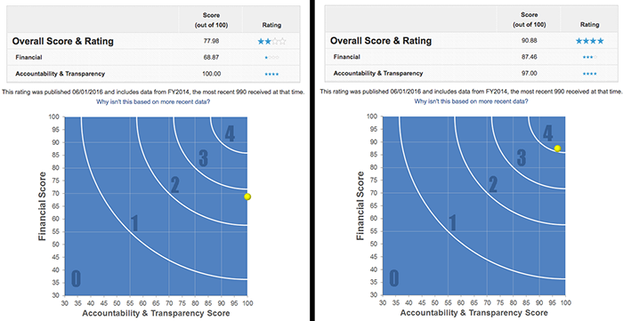

**Effectiveness manipulation, Study 5**

**(grey introductory text is the same as in the control condition)**

**What is polio?**

Poliomyelitis (polio) is a highly infectious disease caused by the polio virus. It invades the nervous system, and can cause paralysis or even death in a matter of hours.

**Who is at risk of catching polio?**

Polio mainly affects children under 5 years of age.

**What are the effects of polio?**

One in every 200 persons infected with polio leads to irreversible paralysis (usually in the legs). Among those paralysed, 5-10% die when their breathing muscles are immobilized by the virus.

**Is there a cure for polio?**

Once contracted there is no cure for polio. However, polio can be prevented by immunization. A safe and effective vaccine exists - the oral polio vaccine (OPV). Given multiple times, it protects a child for life. One dose of OPV can cost as little as 14 US cents.

**Why is so much focus placed on polio, but not on other diseases?**

Polio is one of only a few diseases which can be completely eradicated, such as was the case with smallpox. There are 3 strains of wild poliovirus, none of which can survive for long periods outside of the human body. If the virus cannot find an unvaccinated person to infect, it will die out. Polio eradication infrastructures are also used for the provision of other health services such as deworming tablets, vitamin A and bednets.  
  
**How far have we come in the process of eradicating polio?**  
In 1988, when the Global Polio Eradication Initiative was formed, polio paralysed more than 350,000 people a year. In 2013, only 416 polio cases reported. We are 99% of the way to eradicating polio globally. The world can be freed of the threat of polio - with everyone's commitment to overcome the last 1%.

**Is the quest to eradicate polio worth all the money invested in it?**

Yes, at least according to economists evaluating these efforts. The following is part of a summary from a scientific paper examining that very question:

"We estimate incremental net benefits of the GPEI [global polio eradication initiative] between 1988 and 2035 of approximately 40–50 billion dollars (2008 US dollars; 1988 net present values). […] The total economic costs saved per prevented paralytic poliomyelitis case drive the incremental net benefits […] This study finds a strong economic justification for the GPEI despite the rising costs of the initiative”.

**Control condition, Study 5**

**What is polio?**

Poliomyelitis (polio) is a highly infectious disease caused by the polio virus. It invades the nervous system, and can cause paralysis or even death in a matter of hours.

**Who is at risk of catching polio?**

Polio mainly affects children under 5 years of age.

**What are the effects of polio?**

One in every 200 persons infected with polio leads to irreversible paralysis (usually in the legs). Among those paralysed, 5%-10% die when their breathing muscles are immobilized by the virus.

**Is there a cure for polio?**

Once contracted there is no cure for polio.

**How does Polio spread?**

Polio is spread through person-to-person contact. When a child is infected with wild poliovirus, the virus enters the body through the mouth and multiplies in the intestine. It is then shed into the environment through the faeces where it can spread rapidly through a community, especially in situations of poor hygiene and sanitation.

Young children who are not yet toilet-trained are a ready source of transmission, regardless of their environment. Polio can be spread when food or drink is contaminated by faeces. There is also evidence that flies can passively transfer poliovirus from faeces to food.  
  
Even symptomless people carry the virus in their intestines and can “silently” spread the infection to thousands of others before the first case of polio paralysis emerges. For this reason, WHO considers a single confirmed case of polio paralysis to be evidence of an epidemic – particularly in countries where very few cases occur.

**What are the standards for detecting a circulation of poliovirus?**

Among other things, all acute flaccid paralysis (AFP) cases under 15 years of age or with paralytic illness at an age where polio is suspected should be reported immediately and investigated within 48 hours, and two stool specimens should be collected 24-48 hours apart and within 14 days of the onset of paralysis.

**What can be done in terms of basic hygiene to avoid polio?**

Wash your hands often. If soap and water aren’t available, clean hands with hand sanitizer (containing at least 60% alcohol). Don’t touch your eyes, nose, or mouth. If you need to touch your face, make sure your hands are clean.

# **Effectiveness manipulation, Study 6**

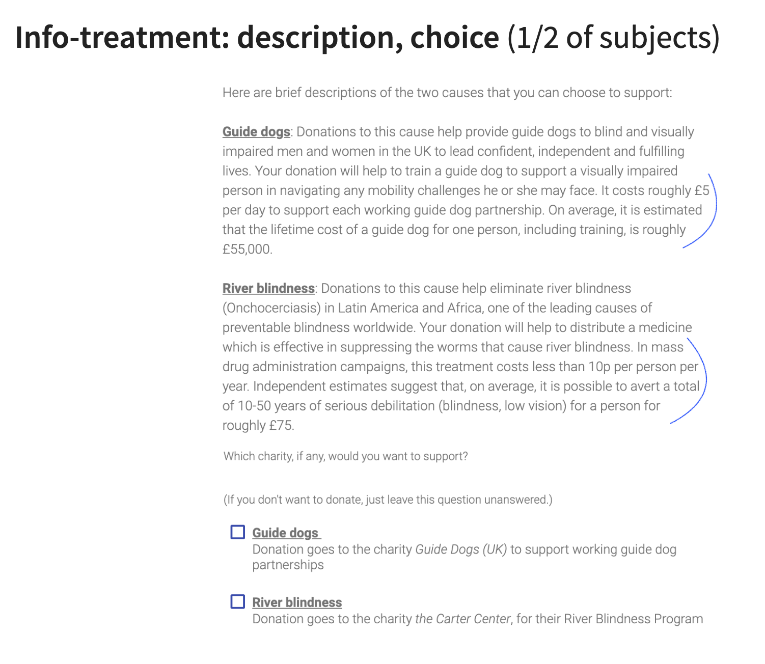

The Control screen was similar, but the last two sentences of each paragraph (indicated above in blue pen; starting with ‘It costs roughly £5 per day’ and with ‘In mass drug administration campaigns’) were not shown in the Control versions.

**Donation questions**

In all studies, except the last one, participants were asked if they would be willing to donate (yes/no) before being asked about amounts to donate. For each study, participants in all conditions were asked the same questions. The studies varied in terms of whether donations were made from a bonus (study 1,2, and 5) or prospective raffle winnings (study 3,4, and 6). The amounts and odds of winning the raffle also varied, as well as the particular cause the participants could support (see manuscript for more information).

Below is an example from study 3.

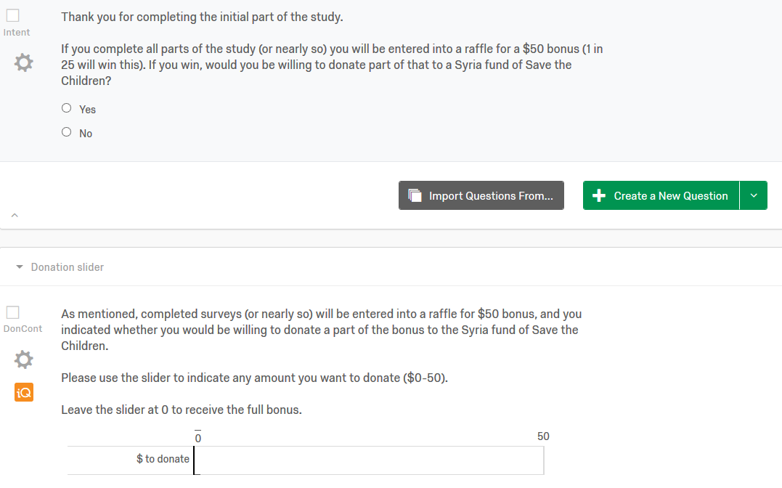

**Additional Results**

**Results including inattentive participants**

We also reran the analyses based on data from all participants who completed any of the measures in the study (i.e. including the participants who failed the attention checks).

*Table S1.* Regression coefficients for experimental manipulations in Study 1 (*N* = 438).

|  |  |  |  |  |  |  |  |  |  |
| --- | --- | --- | --- | --- | --- | --- | --- | --- | --- |
| **Unstandardized results** | | | | | | | | | |
|  | **DONATE: NO (0) / YES (1)** | | |  | | **DONATED (NON-ZERO) AMOUNTS** | | | |
|  | ***B*** | **S.E.** | ***P*** | |  | | ***B*** | **S.E.** | ***p*** |
| IM05 | 0.406 | 0.200 | 0.042 | |  | | 0.203 | 0.117 | 0.082 |
| EFF05 | -0.190 | 0.200 | 0.343 | |  | | 0.089 | 0.117 | 0.445 |
| IMXEFF | -0.242 | 0.400 | 0.545 | |  | | -0.325 | 0.233 | 0.164 |

*Note*. EFF05 = Efficiency information manipulation (effect coded: +/-0.5), IM05 = Image manipulation (effect coded: +/-0.5), IMXEFF = Image × Efficiency information.

*Table S2.* Regression coefficients for experimental manipulations in study 2 (*N* = 668).

|  |  |  |  |  |  |  |  |  |  |
| --- | --- | --- | --- | --- | --- | --- | --- | --- | --- |
|  | **DONATE: NO (0) / YES (1)** | | |  | | **DONATED (NON-ZERO) AMOUNTS** | | | |
|  | ***B*** | **S.E.** | ***p*** | |  | | ***B*** | **S.E.** | ***p*** |
| IM05 | 0.129 | 0.161 | 0.423 | |  | | 0.118 | 0.090 | 0.189 |
| EFF105 | -0.175 | 0.226 | 0.441 | |  | | 0.026 | 0.128 | 0.840 |
| EFF205 | -0.182 | 0.227 | 0.423 | |  | | 0.014 | 0.132 | 0.915 |
| IMXEFF | 0.137 | 0.453 | 0.762 | |  | | -0.527 | 0.257 | 0.040 |
| IMXEFF2 | 0.095 | 0.454 | 0.835 | |  | | -0.306 | 0.263 | 0.245 |

*Note.* EFF105 = Positive efficiency information manipulation (effect coded: +/-0.5), EFF205 = Negative efficiency information manipulation (effect coded: +/-0.5), IM05 = Image manipulation (effect coded: +/-0.5), IMXEFF = Image × Positive efficiency information, IMXEFF2 = Image × Negative efficiency information.

*Table S3.* Regression coefficients for experimental manipulations in study 3 (*N* = 681).

|  |  |  |  |  |  |  |  |  |  |
| --- | --- | --- | --- | --- | --- | --- | --- | --- | --- |
|  | **DONATE: NO (0) / YES (1)** | | |  | | **DONATED (NON-ZERO) AMOUNTS** | | | |
|  | ***B*** | **S.E.** | ***p*** | |  | | ***B*** | **S.E.** | ***p*** |
| IM05 | 0.207 | 0.190 | 0.276 | |  | | 2.837 | 1.295 | 0.028 |
| EFF105 | -0.304 | 0.261 | 0.245 | |  | | 1.106 | 1.880 | 0.556 |
| EFF205 | -0.054 | 0.268 | 0.839 | |  | | -1.473 | 1.787 | 0.410 |
| IM05 | 0.207 | 0.190 | 0.276 | |  | | 2.837 | 1.295 | 0.028 |
| IMXEFF | -0.151 | 0.523 | 0.773 | |  | | -0.344 | 3.760 | 0.927 |
| IMXEFF2 | 0.488 | 0.535 | 0.362 | |  | | -0.557 | 3.575 | 0.876 |

*Note.* EFF105 = Positive efficiency information manipulation (effect coded: +/-0.5), EFF205 = Negative efficiency information manipulation (effect coded: +/-0.5), IM05 = Image manipulation (effect coded: +/-0.5), IMXEFF = Image × Positive efficiency information, IMXEFF2 = Image × Negative efficiency information.

*Table S4.* Regression coefficients for experimental manipulations in study 4 (*N* = 657).

|  |  |  |  |  |  |  |  |  |  |
| --- | --- | --- | --- | --- | --- | --- | --- | --- | --- |
|  | **DONATE: NO (0) / YES (1)** | | |  | | **DONATED (NON-ZERO) AMOUNTS** | | | |
|  | ***B*** | **S.E.** | ***p*** | |  | | ***B*** | **S.E.** | ***p*** |
| IM05 | 0.234 | 0.193 | 0.225 | |  | | 4.383 | 1.276 | 0.001 |
| EFFI05 | 0.182 | 0.277 | 0.512 | |  | | -2.435 | 1.742 | 0.162 |
| EFFA05 | -0.327 | 0.268 | 0.221 | |  | | -0.274 | 1.853 | 0.883 |
| IMXEFFI | 0.706 | 0.554 | 0.203 | |  | | -5.431 | 3.484 | 0.119 |
| IMXEFFA | -0.464 | 0.535 | 0.386 | |  | | 0.819 | 3.707 | 0.825 |

*Note.* EFFI05 = Early efficiency comparison (effect coded: +/-0.5), EFFA05 = Late efficiency comparison (effect coded: +/-0.5), IM05 = Image manipulation (effect coded: +/-0.5), IMXEFFA = Image × Late efficiency comparison, IMXEFFI = Image × Early efficiency comparison

*Table S5.* Regression coefficients for experimental manipulations in Study 5 (*N* = 455).

|  |  |  |  |  |  |  |  |  |  |
| --- | --- | --- | --- | --- | --- | --- | --- | --- | --- |
|  | **DONATE: NO (0) / YES (1)** | | |  | | **DONATED (NON-ZERO) AMOUNTS** | | | |
|  | ***B*** | **S.E.** | ***p*** | |  | | ***B*** | **S.E.** | ***p*** |
| IM05 | 0.515 | 0.191 | 0.007 | |  | | 0.077 | 0.196 | 0.693 |
| EFF05 | -0.010 | 0.191 | 0.959 | |  | | 0.116 | 0.196 | 0.552 |
| IMXEFF | 0.339 | 0.381 | 0.373 | |  | | -0.540 | 0.391 | 0.167 |

*Note*. EFF05 = Efficiency information manipulation (effect coded: +/-0.5), IM05 = Image manipulation (effect coded: +/-0.5), IMXEFF = Image × Efficiency information.

*Table S6.* Regression coefficients for experimental manipulations in Study 6 (*N* = 378).

|  |  |  |  |  |  |  |  |  |  |
| --- | --- | --- | --- | --- | --- | --- | --- | --- | --- |
|  | **DONATE: NO (0) / YES (1)** | | |  | | **DONATED (NON-ZERO) AMOUNTS** | | | |
|  | ***B*** | **S.E.** | ***p*** | |  | | ***B*** | **S.E.** | ***p*** |
| IM05 | -0.001 | 0.206 | 0.997 | |  | | -2.253 | 1.984 | 0.258 |
| EFF05 | 0.021 | 0.206 | 0.920 | |  | | -1.565 | 1.984 | 0.431 |
| IMXEFF | 0.212 | 0.412 | 0.607 | |  | | 3.726 | 3.968 | 0.349 |

*Note*. EFF05 = Efficiency information manipulation (effect coded: +/-0.5), IM05 = Image manipulation (effect coded: +/-0.5), IMXEFF = Image × Efficiency information.

# Donation rates by study

|  | **Total** | **1** | **2** | **3** | **4** | **5** | **6** |
| --- | --- | --- | --- | --- | --- | --- | --- |
|  | n = 3423 | n = 453 | n = 694 | n = 725 | n = 676 | n = 497 | n = 378 |
|  |  |  |  |  |  |  |  |
| **Donated** | 0.6 (0.5) | 0.6 (0.5) | 0.6 (0.5) | 0.7 (0.4) | 0.8 (0.4) | 0.5 (0.5) | 0.5 (0.5) |
| **Don Share** | a | 1.0 (1.1) | 1.0 (1.1) | 16.9 (16.4) | 18.4 (16.4) | 1.4 (1.8) | 9.3 (13.4) |
| **Don Share** | 0.3 (0.3) | 0.3 (0.4) | 0.3 (0.4) | 0.3 (0.3) | 0.4 (0.3) | 0.3 (0.4) | 0.2 (0.3) |

*Note*. Table reports means and standard deviations for each variable. Donated: NO (0) / YES (1) = Dichotomous two-part outcome (Donated: Yes/no), Donation: Amounts including zeroes (in $ or £), Don Share: Share of maximum amount ($3, $3, $50, $50, $5, £50, respectively) donated.

a We do not report average donation across studies because the maximum possible donations and currencies differed.

# Conditional-on-positive Treatment effects: Lee (2009) bounded estimates

As Lee (2009) explains, if treatments have an impact on selection into a particular *selection group*, and the composition of those selected into this *group* differs by treatment according to some *outcome*, then estimates comparing the *outcome* for treatment and control participants who are in this *selection group* will be biased. More specifically, if we compare the mean donation for treatment and control participants *throwing out all those who did not donate,* this naïve ‘conditional-on-positive’ estimate is potentially biased.[1]

The “Lee-bound” procedure can recover *the impact of the treatment on the outcome, for those who would have been in the relevant ‘selected’ group whether or not they received the treatment*

under a ‘monotonicity condition’:

* + essentially, the treatment must make it either *more* or *less* likely that individuals select into the group (make a positive donation),
  + but it must not be that the treatment induces *some* individuals to select in (donate) who would not have otherwise done so, and *other* individuals to select out (not donate) who would have otherwise selected in.

Given this, the observed donors in the treatment (control) that induces a *greater likelihood of donation* would also have donated in the other treatment, but not vice-versa. To recover an asymptotically unbiased estimate of the impact of the treatment on “those who would always have donated”, an “apples to apples” comparison, we would need to “throw out” the participants in this treatment group who would not have donated under the other treatment.

Although we do not know who these “donate only in one treatment” people are, the bias will be greatest if these are the *largest* or *smallest donors.* This motivates the Lee-bound trimming procedure. The procedure amounts to “…amounts to first identifying the excess number of individuals who were induced to be selected … because of the treatment and then trimming the upper and lower tails of the outcome… distribution by this number, yielding a worst-case scenario bound.” Bounds can be further tightened by doing the above *within* groups (identified by a baseline characteristic – in our case we use the study number and the alternate treatment arm, yielding 12 cells) and taking a weighted average of these. We can tighten these further as bounds on the *average treatment effect* (those reported in bold below); the details of this are rather technical.

We report the results below for the pooled data (meta-analysis) across six studies, focusing on the amounts donated share of the maximum possible amount one could donate, and reporting results for each treatment separately.

**Lee Bounds on impact of *Image* treatment on “share of maximum possible amount donated” for those who would donate a positive amount with or without the *Image* treatment**

Tightened Lee (2009) treatment effect bounds

Number of obs. = 3322

Number of selected obs. = 2209

Number of cells = 12

Overall trimming proportion = 0.0786

**Effect 95% conf. interval : [-0.0172 0.1192]**

------------------------------------------------------------------------------

| Observed Bootstrap Normal-based

don_share_ | Coef. Std. Err. z P>|z| [95% Conf. Interval]

-------------+----------------------------------------------------------------

im05 |

lower | .0131366 .0184498 0.71 0.476 -.0230244 .0492975

upper | .0886843 .018538 4.78 0.000 .0523505 .125018

**Lee Bounds on impact of *Effectiveness Information* treatment on “share of maximum possible amount donated” for those who would donate a positive amount with or without the *Effectiveness Information* treatment**

Tightened Lee (2009) treatment effect bounds

Number of obs. = 2872

Number of selected obs. = 1896

Number of cells = 12

Overall trimming porportion = 0.0146

**Effect 95% conf. interval : [-0.0652 0.0423]**

------------------------------------------------------------------------------

| Observed Bootstrap Normal-based

don_share_~y | Coef. Std. Err. z P>|z| [95% Conf. Interval]

-------------+----------------------------------------------------------------

eff05 |

lower | -.034899 .0184408 -1.89 0.058 -.0710422 .0012442

upper | .0123167 .0182411 0.68 0.500 -.0234352 .0480687

------------------------------------------------------------------------------

The 95% confidence bounds on the CoP treatment effect of the Image include a small (-1.7%) negative and a moderate positive (11.9%) effect.

The 95% confidence bounds on the CoP treatment effect of the *Effectiveness Information* include a moderate (-5.7%) negative and a moderate positive (4.2%) effect; loosely speaking we can statistically rule out that this treatment had a large CoP effect in either direction.

**Lee Bounds on impact of *Effectiveness Information* in the presence of *Image Treatment* on “share of maximum possible amount donated” for those who would donate a positive amount with or without the *Effectiveness Information* treatment**

Although we cannot incorporate interaction effects in this bounding estimator in a straightforward way, we present below a similar estimate of the *impact of the Effectiveness treatment in the presence of the Image treatment*, i.e., only for the set of observations where the Image treatment is present.

Number of obs. = 1432

Number of selected obs. = 985

Number of cells = 6

Overall trimming porportion = 0.0044

**Effect 95% conf. interval : [-0.1012 0.0062]**

------------------------------------------------------------------------------

| Observed Bootstrap Normal-based

don_share_~y | Coef. Std. Err. z P>|z| [95% Conf. Interval]

-------------+----------------------------------------------------------------

eff05 |

lower | -.0626289 .0230794 -2.71 0.007 -.1078637 -.017394

upper | -.0348458 .0245779 -1.42 0.156 -.0830176 .0133259

------------------------------------------------------------------------------

Note that the 95% confidence interval for this effect includes a fairly large (10%) negative effect and only a very small positive effect (0.6%).

# Pooled-data regressions (meta-analysis); includes attentive and non-attentive participants

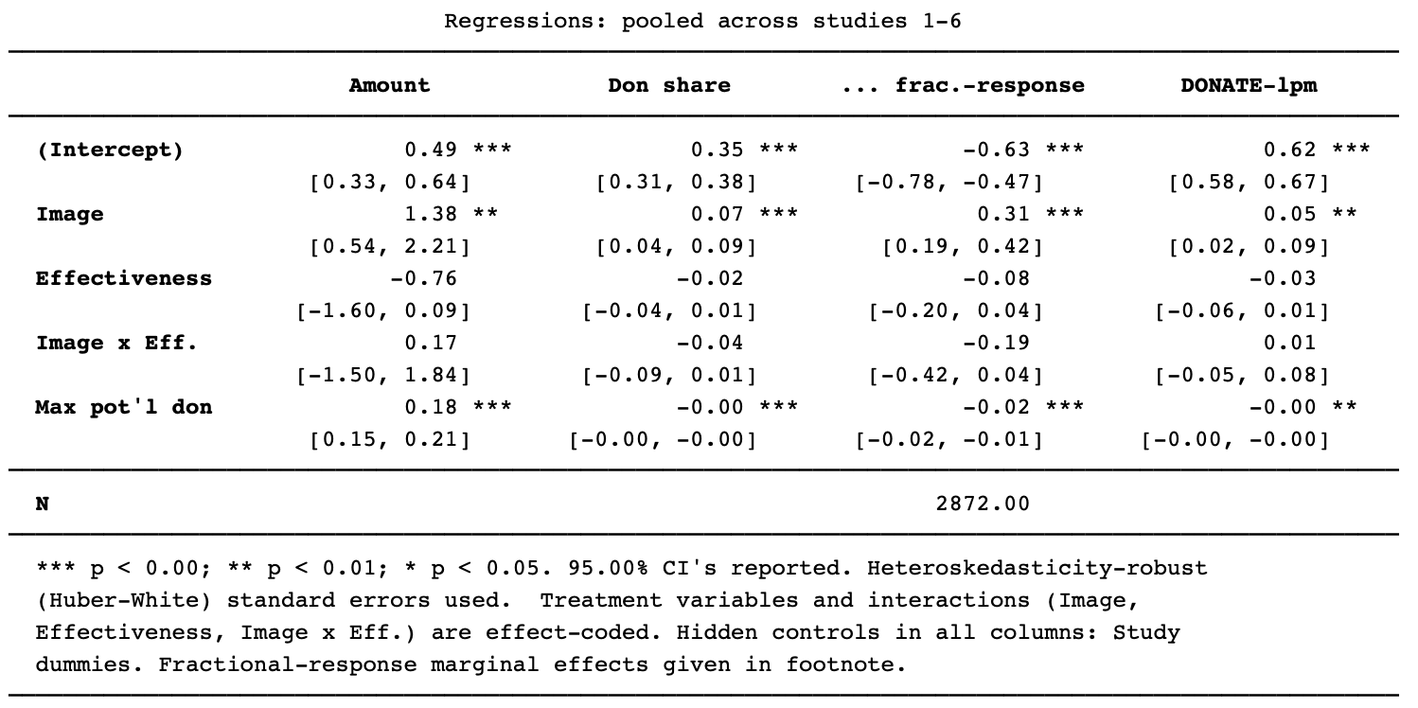

Column 1 gives an OLS regression of amount donated (including zeroes). Columns 2-3 regress on the Share of maximum potential donation (“Max pot’l don”: $3, $3, $50, $50, $5, £50, for studies 1-6 respectively)

# Study 6: Impact on donations to each charity (all participants)

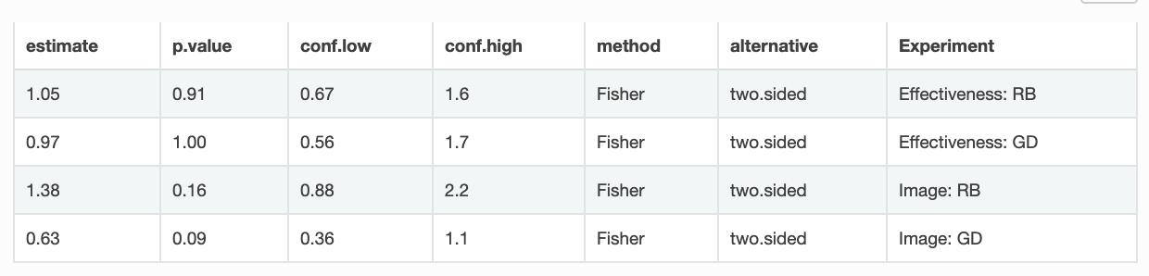

Above we see estimated of odds ratios, relative to the control group, of the incidence of donating to RB (Carter Center: the river-blindness charity) and GD (Guide Dogs for the blind). Confidence intervals reveal a lack of power. However, there is suggestive evidence (p=0.09 and p=0.16, respectively) that the image lead people to be less-likely to donate to GD and more likely to donate to RB. This may have been driven by the African appearance of the blind girl depicted.

As suggested by the box-plot below (means in red), there is also some evidence that the image treatment led to a lower *average* donation to GD (including zeroes). There is a (marginally) significant difference between the control and the Image treatment in a t-test (p=0.035) nd rank-sum test, p=0.059). (As always, all tests are two-tailed.)

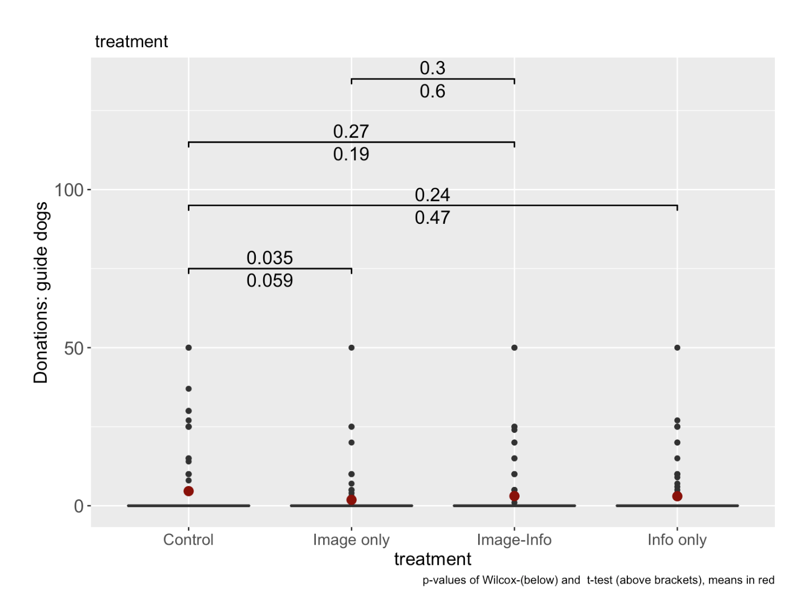

# Study 6: donation distributions (all participants)

As seen below, the distribution of donations was roughly similar across treatments.

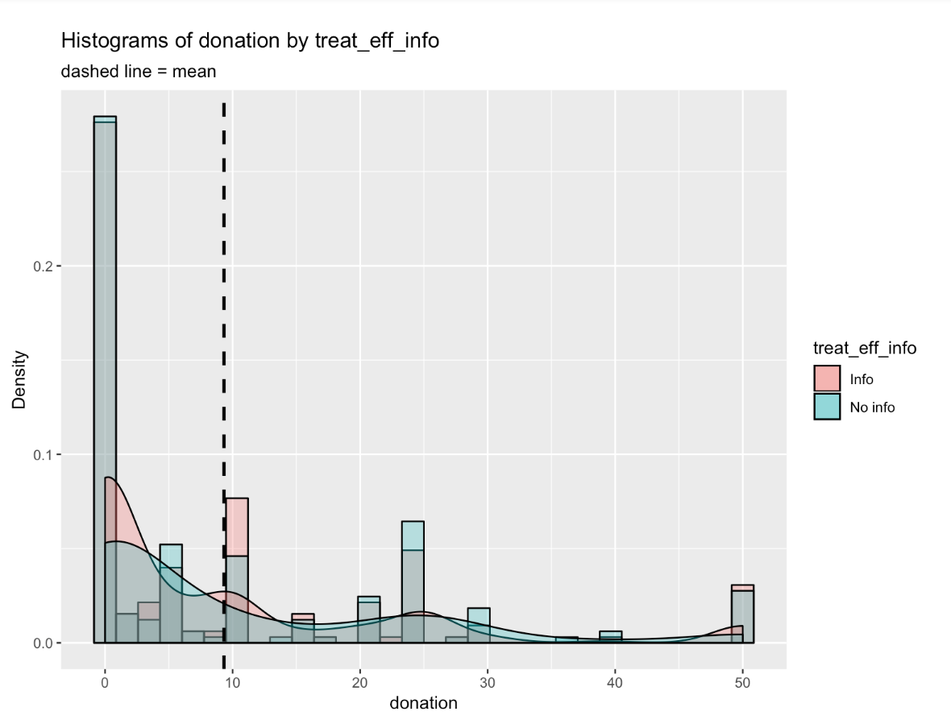

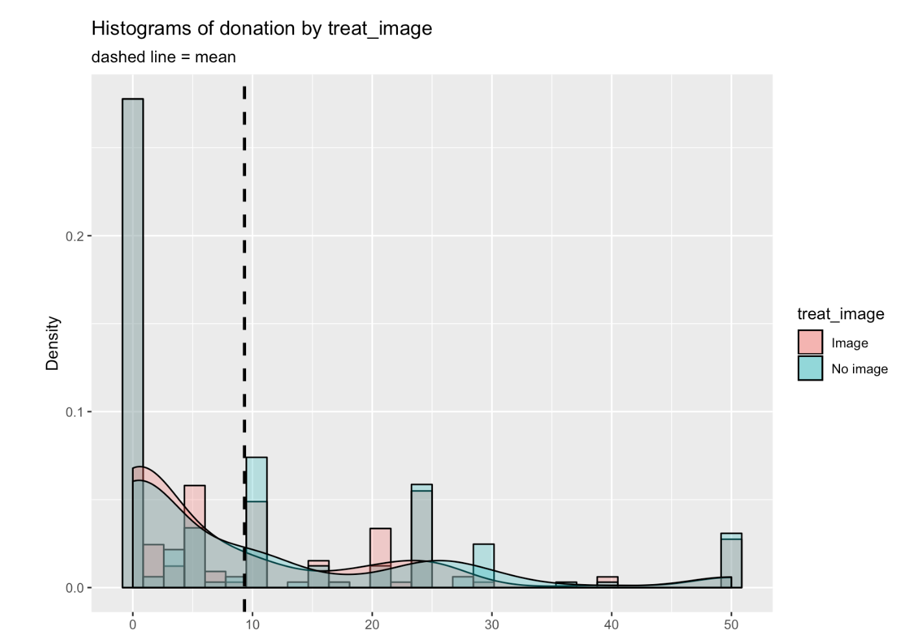

1. For example, suppose a treatment increased the inclination to donate, increasing the donation among those who would have donated anyway, and making those who were “almost willing to donate” do so. However, the latter group may reasonably make the *smallest* donations. This would drive down the measured “average positive donation” in the treatment group relative to the control group.